The Skyflower Ensemble presents

La Circe

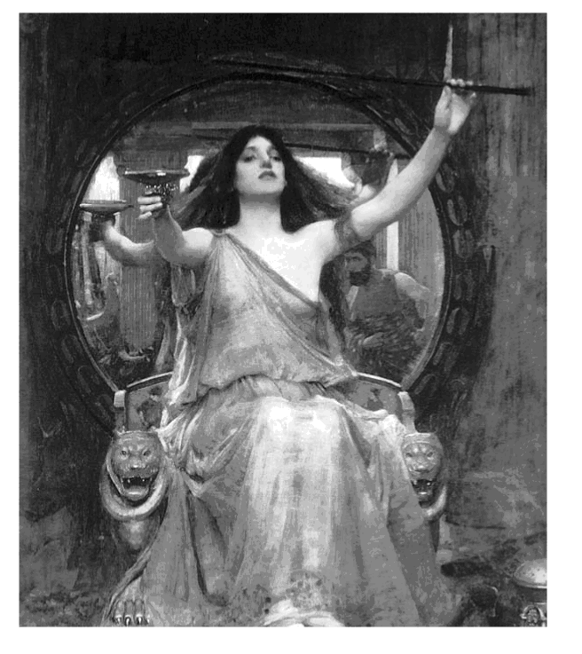
A 17th Century Cantata by Alessandro Stradella
Skyflower performers include Olivia Tennant, narrator, Lauren Hanzel, dancer, Gael Reed soprano,
Beth Freeman soprano, Richard Stumpf bass, Felicia Mcfall and Muftiah Martin baroque violins,
Sarge Gerbode lute, Gary Digman and Robin Easterbrook,bass gambas.
Thursday March 30, 2006, 7:00pm.
Herold Mahoney Library, 680 Sonoma Mt. Parkway, Petaluma
For more information, call: (707) 778-3974 Free Event • Parking Permits Required
Saturday, April 1st , 2006, 8:00pm.
First United Methodist Church; 1551 Montgomery Drive; Santa Rosa
For More Information, Call: (707) 526-7039. Suggested donation $10.00
Tickets for this performance available at Stanroy Music Center in Santa Rosa
and People’s Music in Sebastopol

