Very brief and informal introduction
to understand and learn by yourself to play all songs intabulated for lute, with the manner of tuning the said lute.
Altogether 39 songs, the most part of which are in two formats, i.e. in two parts with [mensural] music and tablature and in three parts without the [mensural] music.
Printing of all this was completed on the 6th day or October, 1529. By Pierre Attaingnant, residing in Paris on the Rue de la Harpe, near the Saint Cosme church, of which the table of contents follows:

A toy me rends fol. 6
Amy, souffrez 9
Amour vault trop 33
C’est boucane 8
Ces falcheux sotz 25
Dulcis amica 7
De retourner 17
Dolent depart 27
D’ou vient cela 37
D’estre amoureux 51
D’amours je suis 57
De toy me plainctz 58
Elle s’en va 58
Fortune, laisse moy 9
Fortune a bien tourné 42
J’ay trop aimé 13
J’atens secours 23
Je me repens 29
Je demeure seulle 31
Il me suffit 39
Joyssance 49
Languir me fais 19
Las, pour quoy 41
Le dur regret 43
Las, il faudra 45
Le jaune & blanc 47
La guerre 59
Prelude 2
Prelude 3
Prelude 4
Prelude 5
Prelude 9
Si vostre cueur 15
Secoures moy 35
Si j’ay pour vous 55
Tant que vivray 53
Tresoriere 50
Vivray ie tousjours 21
Un bergerote 45

By privilege of the King, our lord, for three years, that, in this kingdom, no one may print or have printed this music and lute [tablature] except the said Attaingnant, under the penalties contained in the text of the said privilege.
Three brief rules to be quickly and easily introduced to lute tablature.

- First rule: The handle or neck of the lute has eight frets, of which the first should be designated by , the 2nd by , the 3rd by , the 4th by , the 5th by , the 6th by , the 7th by
, the 8th by   And sometimes the 9th stop is done on the beginning of the belly of the
lute, which is designated by k.   is not at all designated as being on the said neck
because the string it comes on is not stopped on the said neck but only touched on the
belly [by the right hand].
- Second rule: The lute has 11 strings, ordered in six courses, of which the first begins with the first thick string, and its companion, which are designated as being in the space underneath the five lines of the tablature [staff], which five lines represent the other five courses of strings, namely: the first line [on the bottom of the staff] represents the second course, the second the third [course], the third line the 4th course, the fourth [line] the fifth [course], and the [fifth] [line] the 6th course. And note that the letters placed on the said space [under the tab staff] as well as on the said five lines should be stopped on the neck by the left hand, each held and ordered by the rhythm flags, as described below. And when two or three of these come one on top of another, they should be held all together. Also note that those that have a dot under them should be plucked by the [fore]finger and the others by the thumb.
- Third rule: There are five types of rhythm flags or signs by which all intabulated songs are plucked, such as longs or breves, etc. These signs represent 5 sorts of musical notes. The first is marked thus: and has the value of a semibreve. The second is thus: 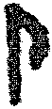 and has the value of a minim; two of these have the value of the first. The third is thus:  and has the value of a semiminim, and it takes 4 of them to [equal] the first & 2 for the second. The fourth is thus: 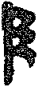 and has the value of a crochet, of which it takes 8 to equal the first, 4 for the second, and 2 for the third. The 5th is thus: , which is not often found and has the value of a fredon, of which it takes 16 to equal the first, 8 for the second, 4 for the third, and 2 for the fourth.
And note that in lute tablature, neither breves, longs, nor maximae are used at all because the sound of each string lasts only as long as a semibreve. For all that has been said, see the following figure:
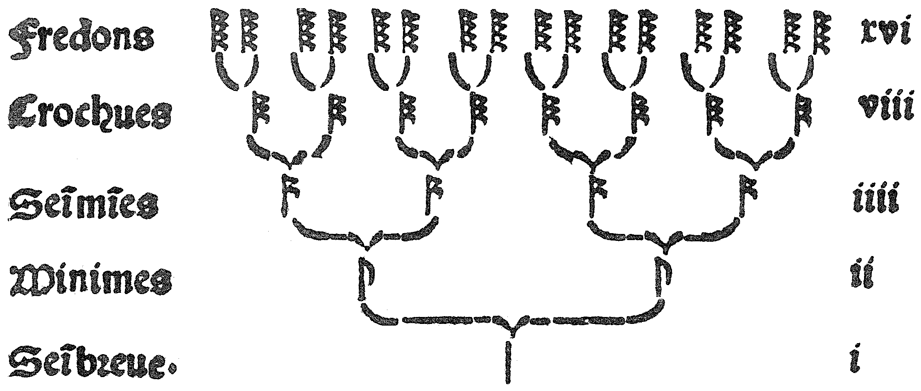
Beside the rhythm flags or the marks below them, there is yet another that comes at the end of songs and is marked thus:  and is called “organ point” and has the value of a semibreve or as much value as you would like to give it. Also, oftentimes a point is found inside the minim and semiminim rhythm flags as thus: 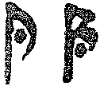; that point augments their values by half again what their value is. Additionally, sometimes a sign like this: 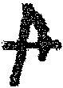 is found amongst the lines of the staff, which denotes a minim rest, or one like this: 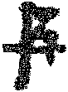, which denotes a semiminim rest.
- To tune the lute: Tune the large string of the first course to as low a pitch as you like., and its companion eight notes higher. Then tune the large string of the second course four notes higher than the first and its companion eight notes higher. And do the same to the large string of the third course and its companion. Then tune the two thinner strings of the fourth course three notes higher than the third course. And the two of the 5th course should be 4 notes higher than the fourth course. And that of the 6th, which is single, should be 4 notes higher than the 5th course. And if you have done this properly,
you will find the  of the first and the 6th courses and the  of the third course (when
sounding them all together) to all be in tune. Then sound together the  of the third
course and the  of the 5th and you will find them well in tune. Afterwards, sound the
 of the 2nd course and the  of the fifth and you will find them well in tune. And
that’s what you have to do to get your lute well tuned. And for all these tunings, see the
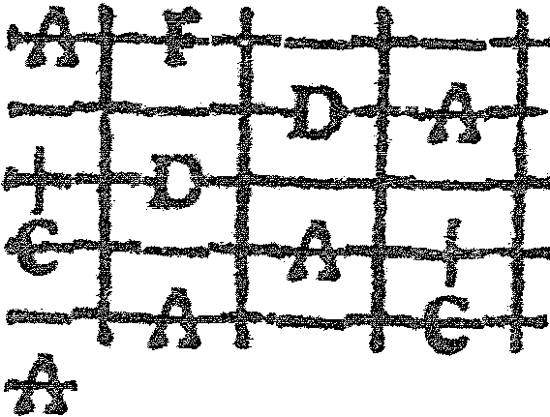
figure given below: And note that, as a general rule, the thick string of the second course is a fourth higher than the thick string of the first course and that of the third course is a fourth higher than the second course. And their companions, however, are an octave higher than the thick ones. And those of the fourth course are a third above the third course. And the two following courses are each a fourth above one another, etc., and those [strings] in each course should be equal in sound and thickness.

Attaingant’s text says “sixth” here, an obvious error.

